Step untuk memfungsikan package apex_mail di platform APEX
Prereq:
- Certificate mail sudah harus ada dulu
- User APEX_240200 tidak locked atau expired
- User Schema di ACL kan
- URL Wallet di OS didaftarkan di workspace internal dengan autologin
- Tentukan SMTP Server, contoh mail.nusamail.net, bisa diping dari server

Step:
- Query cek user APEX_240200
SELECT *
FROM DBA_USERS
WHERE USERNAME LIKE '%APEX%'

- Jika terlock lakukan hal berikut:
ALTER USER APEX_240200 ACCOUNT UNLOCK;
Hasil
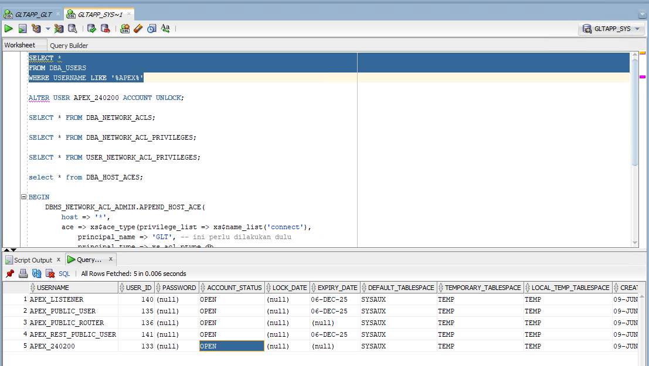
- Buat Append host
BEGIN
DBMS_NETWORK_ACL_ADMIN.APPEND_HOST_ACE(
host => '*',
ace => xs$ace_type(privilege_list => xs$name_list('connect'),
principal_name => 'APEX_240200', -- ini perlu dilakukan dulu, agar bisa dipakai apex_mail nya
principal_type => xs_acl.ptype_db
));
END;

BEGIN
DBMS_NETWORK_ACL_ADMIN.APPEND_HOST_ACE(
host => '*',
ace => xs$ace_type(privilege_list => xs$name_list('connect'),
principal_name => 'GLT, -- schema aplikasinya
principal_type => xs_acl.ptype_db
));
END;

Hasil untuk privilege connect ada tambah 2

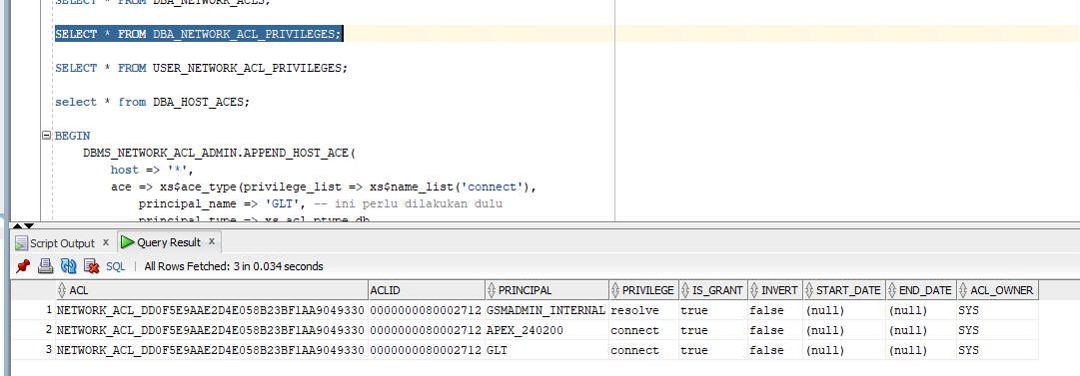
- Buat tools untuk testing url/ip address dari smtp servernya, dan untuk cek port yang berfungsi
create or replace type TStrings as table of varchar2(4000);

CREATE OR REPLACE FUNCTION SmtpTest (server VARCHAR2,
port INTEGER DEFAULT 25)
RETURN TStrings
PIPELINED
IS
smtp UTL_SMTP.connection;

reply UTL_SMTP.reply;
BEGIN
-- attempt to connect to mail server

PIPE ROW ('connecting to server ' || server || ' on ' || port || '/tcp');

reply := UTL_SMTP.open_connection (HOST => server, port => port, c => smtp);

PIPE ROW (reply.Code || '. ' || reply.Text);

-- if a successful connect, gracefully disconnect

IF reply.Code < 400
THEN
reply := UTL_SMTP.quit (smtp);

PIPE ROW (reply.Code || '. ' || reply.Text);
END IF;
END;
/
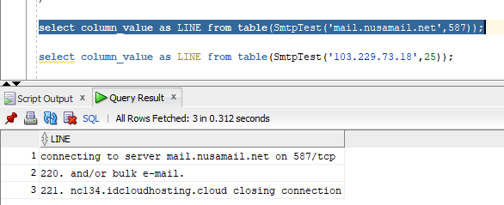

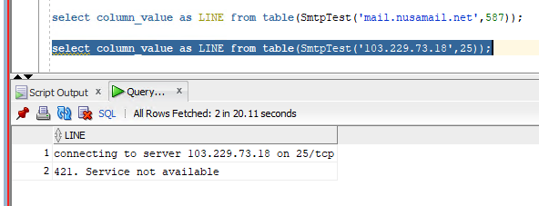

Terlihat port 25 terdapat error 421, port yg dipakai 587, dimana ini tidak menggunakan SSL/TLS

- Setting parameter SMTP
BEGIN
apex_instance_admin.set_parameter('SMTP_HOST_ADDRESS', 'mail.nusamail.net');
apex_instance_admin.set_parameter('SMTP_HOST_PORT', '587');
apex_instance_admin.set_parameter('SMTP_FROM', 'notifications.meta@nusamail.net');
apex_instance_admin.set_parameter('SMTP_USERNAME', 'notifications.meta@nusamail.net');
apex_instance_admin.set_parameter('SMTP_PASSWORD', 'm3t@Notification');
apex_instance_admin.set_parameter('SMTP_TLS_MODE', 'N');
COMMIT;
apex_instance_admin.validate_email_config;
END;

- Testing
begin
apex_mail.send(
p_to => 'iwan.herdian@limamail.net' , -- change to your email address
p_from => 'iwan.herdian@danangwisnu.my.id', -- change to a real senders email address
p_body => 'test',
p_body_html => '<html><body>test</body></html>',
p_subj => 'test email');

apex_mail.push_queue;
end;

cek hasilnya, seharusnya di queue kosong

select *
from apex_mail_queue

Screenshot:
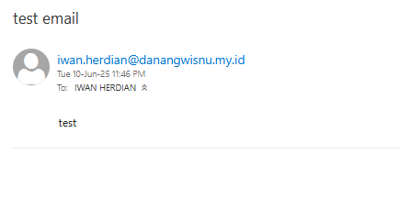
- Sebelumnya perlu tambahkan path wallet, kalau wallet belum pernah dibuat sebelumnya maka perlu buat dahulu
jalankan di console putty/command prompt, nanti sesuaikan saja dengan path OS nya, contoh dibawah kalau linux:
orapki wallet create -wallet "/u01/PROD/wallet2" -auto_login -pwd wallet123
orapki wallet add -wallet "/u01/PROD/wallet2" -trusted_cert -cert "/u01/PROD/wallet2/DigiCertGlobalRootCA.crt" -pwd wallet123
orapki wallet display -wallet "/u01/PROD/wallet2"

Konsep:
You must use the DBMS_NETWORK_ACL_ADMIN package to grant connect privileges to the APEX schema (database user).

This is explained in the Enabling Network Services in Oracle Database section of the APEX Installation Guide.
For example, you can find in this link the APEX 23.1 version of such documentation. For prior APEX versions, you can
find the documentation and Installation Guides in this link, however the steps are the same for all APEX versions.

Note: If using multitenant database, make sure to create the ACLs on the same database where APEX ins installed:
If APEX is installed in a PDB, the ACLs must be created in that PDB. If APEX is installed in the CDB and then being
used in the PDB, then the ACLs must be created in the CDB. See (Doc ID 2582658.1) for more details about this.
To create the ACL, the steps are as follows:

1.- Identify requiered information
Determine the following information for your ACL:

a) APEX Schema — This depends on your APEX version. For example:
For APEX 23.1, the schema is APEX_230100
For APEX 21.2 the schema is APEX_210200
For APEX 19.2 the schema is APEX_190200

b) Hostname — The URL where APEX will connect to. For example:
To allow connection to a specific URL, use the format: "example.com"
To allow connection to any host, use an asterisk: "*"

c) Privilege — What kind of connection privilege will be granted. The most common are:
Use 'connect' for UTL_TCP, UTL_SMTP, UTL_MAIL and UTL_HTTP access.
Use 'resolve' for UTL_INADDR name/IP resolution

2.- Create the ACL
Connect to the Database using SQL*Plus (or a similar tool) as SYS user, and execute the following code, by replacing
the placeholders <apex_schema>, <hostname>, and <privilege>:

BEGIN
DBMS_NETWORK_ACL_ADMIN.APPEND_HOST_ACE(
host => '<hostname>',
ace => xs$ace_type(privilege_list => xs$name_list('<privilege>'),
principal_name => '<apex_schema>',
principal_type => xs_acl.ptype_db
)
);
END;
/

Examples

Example 1: Grant connect privilege to APEX 23.1 (APEX_230100) schema to "example.com":

BEGIN
DBMS_NETWORK_ACL_ADMIN.APPEND_HOST_ACE(
host => 'example.com',
ace => xs$ace_type(privilege_list => xs$name_list('connect'),
principal_name => 'APEX_230100',
principal_type => xs_acl.ptype_db
)
);
END;
/

Example 2: Grant connect and resolve privileges to APEX 21.2 (APEX_210200) schema to any host:

BEGIN
DBMS_NETWORK_ACL_ADMIN.APPEND_HOST_ACE(
host => '*',
ace => xs$ace_type(privilege_list => xs$name_list('connect', 'resolve'),
principal_name => 'APEX_210200',
principal_type => xs_acl.ptype_db
)
);
END;
/

3.- Troubleshooting
If you have issues during this process:

a) Refer to the Troubleshooting an Invalid ACL Error section in the APEX documention. For example, you can find
in this link the APEX 23.1 version of such documentation. See this link for documentation of prior APEX versions.

b) Refer to the DBMS_NETWORK_ACL_ADMIN documentation for details about the function call.

c) If issue persist, test connection between the Database and the endpoint URL (outside APEX). For doing so, connect
to SQL*Plus (or similar tool) as SYS and run the query mentioned in Step 3 of the following note:

A Simple Example of Using UTL_HTTP to Access a Secure Web Page (Doc ID 265616.1)

For example:
If the URL is https://example.com, you don´t have a Proxy Server, and your wallet is located in "/u01/wallet" then:

select utl_http.request('https://example.com', NULL, 'file:/u01/wallet', 'wallet_password') from dual;
If the URL doesn't use HTTPS, then its not necesary to specity wallet information. For example:

select utl_http.request('http://example.com') from dual;
This test will help determine if there is some other issue blocking the connection at database leve

